Animoto Vocab Groups
Username/Email Address | Password | Student Names | Term | Term

CREATE A MATH VOCABULARY VIDEO! Unit 7: Working with Data

Vocab Term Assigned:  First Name(s): | Information about term:  (4-5 words only!) | Information about term:  (4-5 words only!) | Information about term:  (4-5 words only!) | Information about term:  (4-5 words only!)
Picture/Image description: | Picture/Image description: | Picture/Image description: | Picture/Image description: | Picture/Image description:
Other ideas:

CREATE A MATH VOCABULARY VIDEO! Unit 7: Working with Data

Vocab Term Assigned:  First Name(s): | Information about term:  (4-5 words only!) | Information about term:  (4-5 words only!) | Information about term:  (4-5 words only!) | Information about term:  (4-5 words only!)
Picture/Image description: | Picture/Image description: | Picture/Image description: | Picture/Image description: | Picture/Image description:
Other Ideas:

Steps:
- Find 5 pictures related to your term and save pictures to the camera roll (you can take pictures too!—no faces!!)
- Open the Animoto app
- Click “Create Video”
- Click “Check out our Tutorial” and swipe through the tutorial
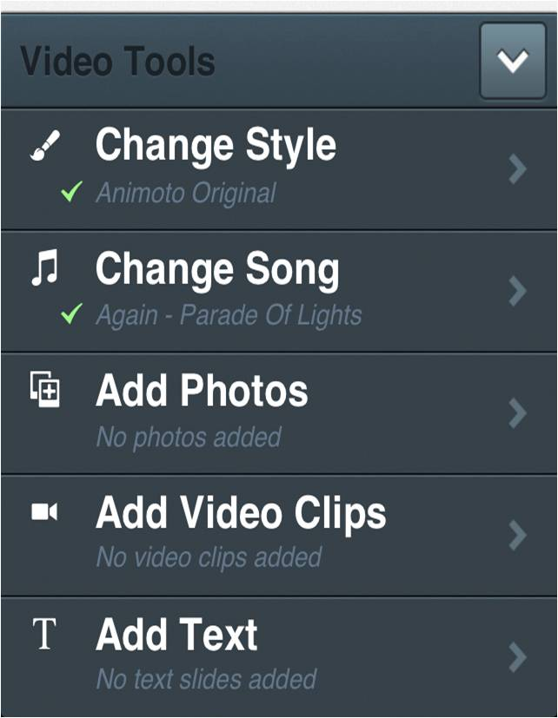
- When you start creating a video, use the ^ up arrow key at the bottom to get the tool options
- Start by adding Photos and Adding Text
- Arrange pictures and text in an order that will help people understand your term/concept
- IF TIME – change the style and/or music to something you think fits the term/concept
- When finished, click the “Preview” button at the top
- Add Title: FIRST names only!
- Add Description: the math term you were assigned
- Click “Finish Video” – be patient until the “Producing” notice disappears – when the “Preparing Video – Take a Break” notice comes up you can move on to another assignment
- Check back on Animoto--when the video is finished, click on the share button at the bottom of the screen
- Select “Email” – email the project to your teacher
- LOG OUT of ANIMOTO – in Animoto - click on the account gear/wheel button at the bottom of the screen
- Select LOG OUT – and then confirm that you want to Log Out!
Teachers – there have been some troubles logging out of Animoto. If students can’t log out, you can delete the app and we can reload it later; however, it may not be available the next day if someone needs Animoto so please inform us!

Steps:
- Find 5 pictures related to your term and save pictures to the camera roll (you can take pictures too!—no faces!!)
- Open the Animoto app
- Click “Create Video”
- Click “Check out our Tutorial” and swipe through the tutorial
- When you start creating a video, use the ^ up arrow key at the bottom to get the tool options
- Start by adding Photos and Adding Text
- Arrange pictures and text in an order that will help people understand your term/concept
- IF TIME – change the style and/or music to something you think fits the term/concept
- When finished, click the “Preview” button at the top
- Add Title: FIRST names only!
- Add Description: the math term you were assigned
- Click “Finish Video” – be patient until the “Producing” notice disappears – when the “Preparing Video – Take a Break” notice comes up you can move on to another assignment
- Check back on Animoto--when the video is finished, click on the share button at the bottom of the screen
- Select “Email” – email the project to your teacher
- LOG OUT of ANIMOTO – in Animoto - click on the account gear/wheel button at the bottom of the screen
- Select LOG OUT – and then confirm that you want to Log Out!
Teachers – there have been some troubles logging out of Animoto. If students can’t log out, you can delete the app and we can reload it later; however, it may not be available the next day if someone needs Animoto so please inform us!

