Animoto Vocab Groups -- Blough
Username/Email Address | Password | Student Names | Term | Term
bloughscience1@gmail.com | wildcats
bloughscience2@gmail.com | wildcats
bloughscience3@gmail.com | wildcats
bloughscience4@gmail.com | wildcats
bloughscience5@gmail.com | wildcats
bloughscience6@gmail.com | wildcats
bloughscience7@gmail.com | wildcats
bloughscience8@gmail.com | wildcats
bloughscience9@gmail.com | wildcats
bloughscience10@gmail.com | wildcats
bloughscience11@gmail.com | wildcats
bloughscience12@gmail.com | wildcats
bloughscience13@gmail.com | wildcats
bloughscience14@gmail.com | wildcats
bloughscience15@gmail.com | wildcats

Steps:
- As a class, watch the sample on rip currents (teacher/librarian will explain how limited the text is – only 52 letters and spaces per slide – it’s like Twitter ) - http://youtu.be/wGp9Xm4wZEo - also on media center channel in the “Currents”playlist.
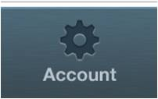
STUDENTS:
- Find 5 pictures related to your term (videos only possible if you can DOWNLOAD a clip to the photo roll)
- Agree with your partner on what you want to teach others about the term(s)
- Open the Animoto app and click on the account gear/wheel in the lower right corner
- Select Log In
- Log in with email above and password (close the Facebook popup window)
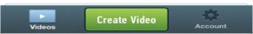
- Click “Create Video”
- Click “Check out our Tutorial” and swipe through the tutorial
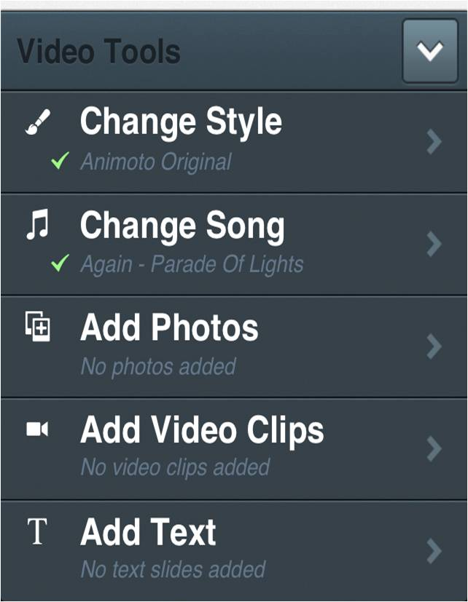
- When you start creating a video, use the ^ up arrow key at the bottom to get the tool options
- Start by adding Photos and Adding Text
- Arrange pictures and text in an order that will help people understand your term/concept
- IF TIME – change the style and/or music to something you think fits the term/concept
- When finished, click the “Preview” button at the top
- Title: group members FIRST names
- Description: the term you were assigned
- Click “Finish Video” – be patient until the “Producing” notice disappears – when the “Preparing Video – Take a Break” notice comes up you can move on to another assignment
- Check back on Animoto--when the video is finished, click on the share button at the bottom of the screen and select “Email” – email the project to your teacher
- LOG OUT of ANIMOTO – in Animoto - click on the account gear/wheel button at the bottom of the screen
- Select LOG OUT – and then confirm that you want to Log Out!
Teachers – there have been some troubles logging out of Animoto. If students can’t log out, you can delete the app and we can reload it later; however, it may not be available the next day if someone needs Animoto so please inform us!

