QR CODES BONES/JOINTS LAB

Name _______________________________ Pd ____

Station 1: Pectoral Girdle
- What bones make up the pectoral girdle?
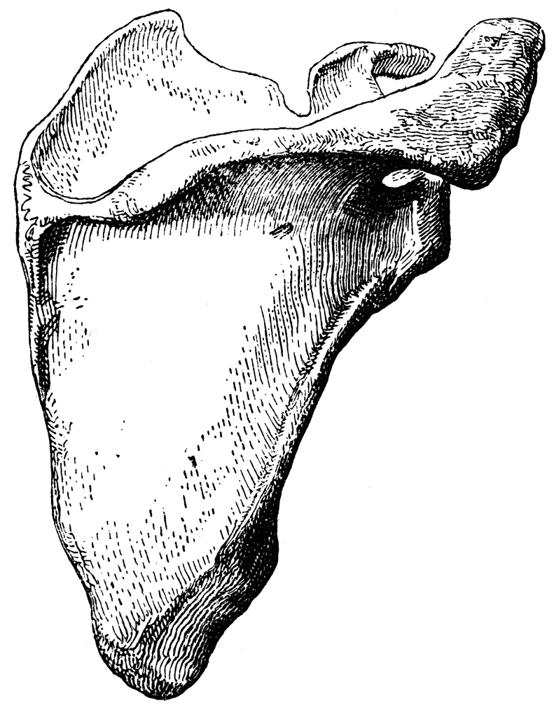
- Identify the important areas on a scapula

- What is the glenoid cavity?
- What type of movement occurs at the glenoid cavity?
- Name some common injuries to the pectoral girdle area-

What was title the best source of information at this station?
On a scale of 1 to 10 (1 being lowest and 10 being highest)…
How EFFECTIVE was this source for answering your station How CREDIBLE was this source? _____
questions? _____ What was the QUALITY of information? _____

Station 2: Upper Extremities- arm, forearm and hand
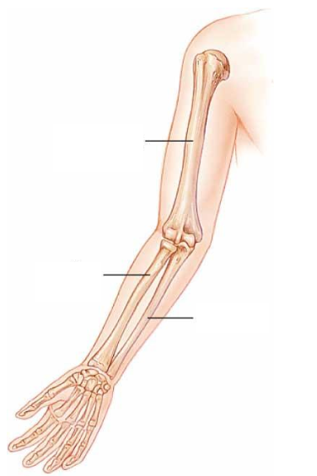
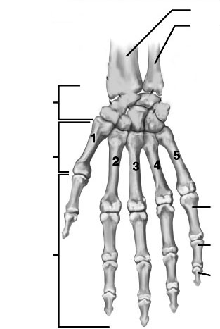
- Label all the bones (30) that make up the upper extremity Carpal Bones:

What was title the best source of information at this station?
On a scale of 1 to 10 (1 being lowest and 10 being highest)…
How EFFECTIVE was this source for answering your station How CREDIBLE was this source? _____
questions? _____ What was the QUALITY of information? _____
Station 3: Lower Extremities- thigh, leg and foot

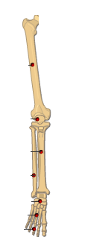
- Label all the bones (29) that make up the lower extremity
Tarsal Bones:
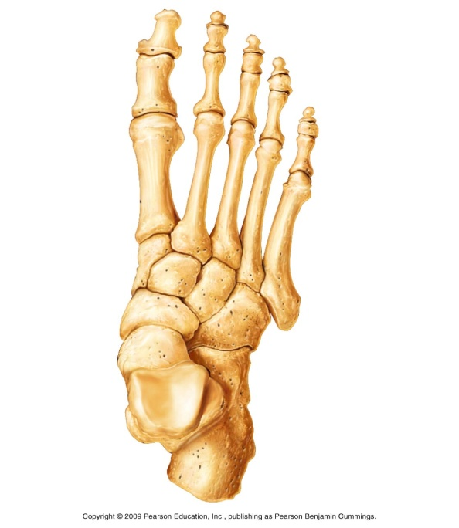

What was title the best source of information at this station?
On a scale of 1 to 10 (1 being lowest and 10 being highest)…
How EFFECTIVE was this source for answering your station How CREDIBLE was this source? _____
questions? _____ What was the QUALITY of information? _____

Station 4: Broken Bones and Fractures

- Describe the process of how broken bones heal

- Define bone fracture-

- List and describe several common types of bone fractures-

What was title the best source of information at this station?
On a scale of 1 to 10 (1 being lowest and 10 being highest)…
How EFFECTIVE was this source for answering your station How CREDIBLE was this source? _____
questions? _____ What was the QUALITY of information? _____

Station 5: Pelvic Girdle

- What bones make up the pelvic girdle?
- What is an alternate name for the pelvic girdle bones?
- What is the acetabulum and describe the type of movement that occurs there

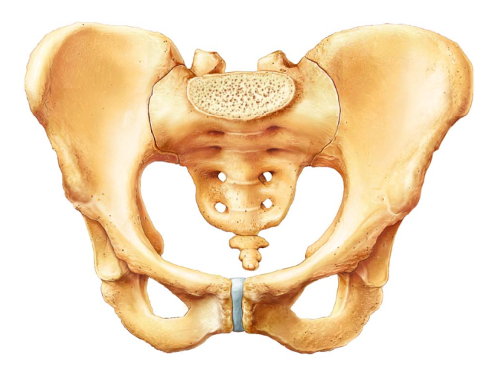
- Label the bones of the pelvic girdle

- Describe a hip replacement

What was title the best source of information at this station?
On a scale of 1 to 10 (1 being lowest and 10 being highest)…
How EFFECTIVE was this source for answering your station How CREDIBLE was this source? _____
questions? _____ What was the QUALITY of information? _____

Station 6: Bone Diseases

- What is osteoporosis?

- Who is commonly affected by osteoporosis?
- What are the risk factors for osteoporosis?

- What is osteogenesis imperfecta?

- What is the cause of osteogenesis imperfecta?

- What is the treatment for osteogenesis imperfecta?

What was title the best source of information at this station?
On a scale of 1 to 10 (1 being lowest and 10 being highest)…
How EFFECTIVE was this source for answering your station How CREDIBLE was this source? _____
questions? _____ What was the QUALITY of information? _____

Station 7: Bone Diseases

- What is Paget’s disease?

- How is Paget’s disease diagnosed?

- What symptoms do people have with Paget’s disease?

- What is scoliosis?
- What signs and symptoms do people have with scoliosis?

- What is the treatment for scoliosis?

What was title the best source of information at this station?
On a scale of 1 to 10 (1 being lowest and 10 being highest)…
How EFFECTIVE was this source for answering your station How CREDIBLE was this source? _____
questions? _____ What was the QUALITY of information? _____

Station 8: Joints and movement

- Name the 3 major types of joints in the body
1.
2.
3.
- Describe the type of movement that each of the major types of joints have
1.
2.
3.
- Name the 6 types of synovial joints and their movements
1.
2.
3.
4.
5.
6.

What was title the best source of information at this station?
On a scale of 1 to 10 (1 being lowest and 10 being highest)…
How EFFECTIVE was this source for answering your station How CREDIBLE was this source? _____
questions? _____ What was the QUALITY of information? _____

Station 9: Comparison of male and female pelvises and skulls

- List several differences between male and female pelvises

- List several differences between male and female skulls

What was title the best source of information at this station?
On a scale of 1 to 10 (1 being lowest and 10 being highest)…
How EFFECTIVE was this source for answering your station How CREDIBLE was this source? _____
questions? _____ What was the QUALITY of information? _____

Station 10: Axial skeleton review

- Name the bones that make up the axial skeleton

- Label the ribs with their alternate names
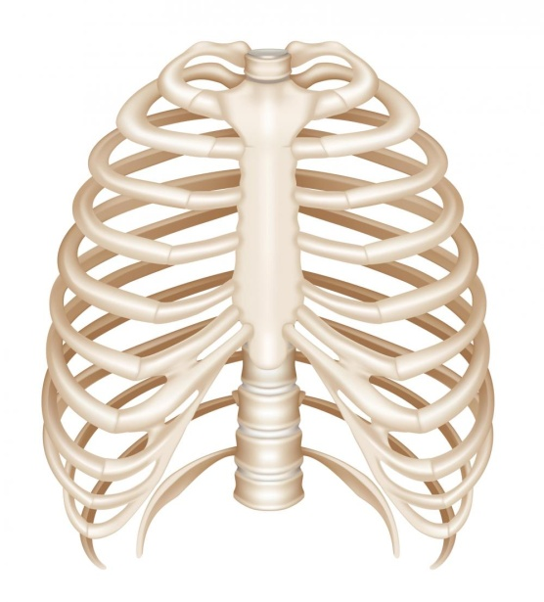
- Describe the differences between the atlas and the axis vertebrae

What was title the best source of information at this station?
On a scale of 1 to 10 (1 being lowest and 10 being highest)…
How EFFECTIVE was this source for answering your station How CREDIBLE was this source? _____
questions? _____ What was the QUALITY of information? _____

