Editing with the iMovie App
iPod Touch
- Write a script and/or create a storyboard for your project
- Show your script/storyboard to the librarian or your teacher to check out a device
- Follow these steps in order to keep organized!

- Record your video, take photos, save photos from the web
2. Open the iMovie App  3. Tap on “My Project 1” to rename your project following your teacher’s guidelines. | 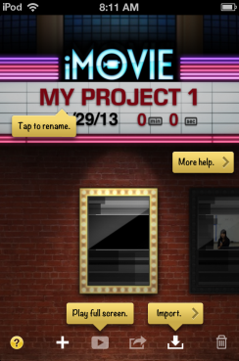 | TIP: Select the “Question” mark for pop up help bubbles – click the question mark again to turn it off  4. Select the + button to be get to the editing screen of the project.
5. Select the theme you want to use (this will include music) – click the settings button to get to themes. | 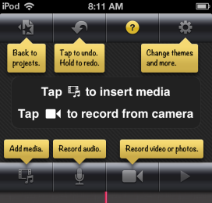 | 6. Use the “Add Media” button to import your video clips and any photos you have taken or saved  TIP: Wait to record additional audio until the video is edited.
7. After you add video clips – tap ONCE on the clip to edit it. While it is selected find the pink line:  - If you swipe your finger “down” on the pink line on the clip then you will cut it into two pieces. You can chop the clips into small pieces and delete parts you don’t want. |  | TIP: Double click on the transition insert to edit transitions after you cut a clip to change the feel of the movie.  TIP: You can drag the yellow circles on the clip to change the pacing or length of a clip
8. Double click on a video clip to get more options.  TIP: You can add subtitles and change the volume of a clip. Subtitles are created with the “Title Style” option | 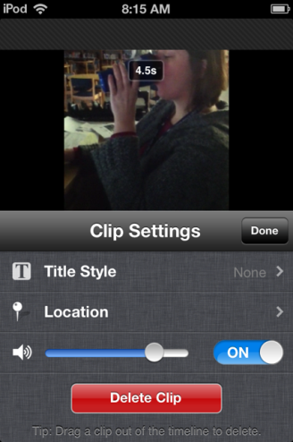 | TIP: If someone makes a mistake talking in a clip, you can turn the volume off for the clip and then later do a voiceover.
9. After you have all the clips edited and you have added any titles, you can add a voice over if necessary with the microphone button. |  | TIP: Periodically during your project, play it to see how it’s looking and what you need to continue working on.
10. When your video is finished, go back to the projects menu and select the “Export” button. |  | 11. Save the movie to the Camera Roll first. Select “Medium” or “Large” (large will take longer)
12. Export to YouTube from iMovie OR the camera roll:  - iMovie – click on the “Export” button and select YouTube – Sign in with your Teacher’s Username and Password or Sign in to your own YouTube account.  - Camera Roll – find the video in the Photo Roll for the device, select the Export button and then select “YouTube” | 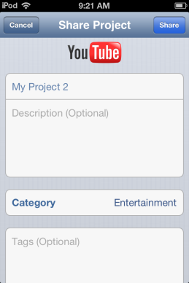 | YouTube Naming Directions:  Title – Based on Assignment Directions from your Teacher  Description – Include your group members First Names and Last Initials  Category – Education  Privacy – Select a privacy level based on your teacher’s direction  Location – do not add a location

NOTE – if YouTube is already signed in, then you will need to sign out of YouTube first – scroll to the bottom of the YouTube screen to find the “Sign Out” button
Other Notes/Assignment Specifics:

