Political Moderates
From WiseGeek.com

The term political moderate can generally be used to describe someone who doesn't hold views on the far edges of the political spectrum. Some of these people may identify with a particular party, or they may describe themselves as independents. If they consider themselves members of a party, a political moderate will often be open-minded about ideas from the opposition parties, and they generally aren't very partisan on many issues.
The actual stance on issues of a political moderate can vary significantly depending on the era and the country they live in. As issues change, the concept of politically moderate viewpoints changes as well. Many people who would have been described as political moderates in the 1800s could be considered fringe extremists in more recent times, and the same can be true for different countries or locations. For example, a moderate viewpoint in one nation might be on the far fringe in another nearby country, and the reasons for these differences may be cultural or religious.
Some individuals who could be described as political moderates actually hold some beliefs that aren't necessarily considered middle-of-the-road. In cases like this, the designation of political moderate is based on the whole spectrum of their political beliefs. Even though they may hold a few beliefs on the far edges, their overall philosophy is much more centrist. Many moderates don’t really feel comfortable with any political party, but their views often lean in one direction or another to some degree.
Learn more about how your moderate views relate to:
Barack Obama | Mitt Romney
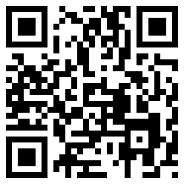 | 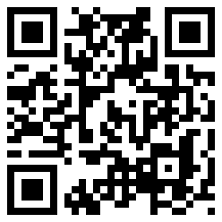
http://www.barackobama.com | http://www.mittromney.com/

