Name:

Keep track of the political parties
that are identified as you work
through each question.

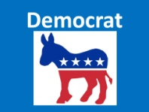 | 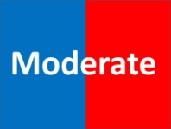
Total Number: | Total Number: | Total Number:

Name:

Keep track of the political parties
that are identified as you work
through each question.

Total Number: | Total Number: | Total Number:

Name:

Keep track of the political parties
that are identified as you work
through each question.
Total Number: | Total Number: | Total Number:

Name:

Keep track of the political parties
that are identified as you work
through each question.
Total Number: | Total Number: | Total Number:

