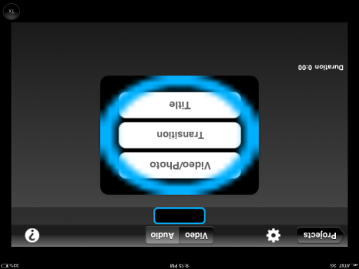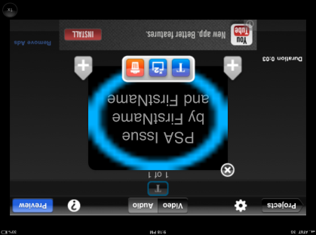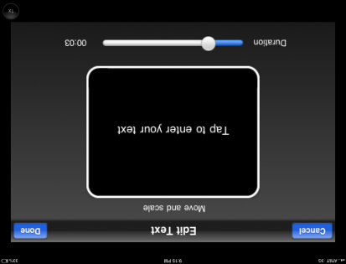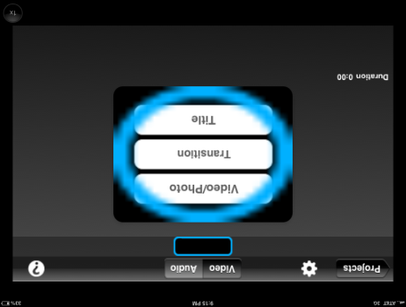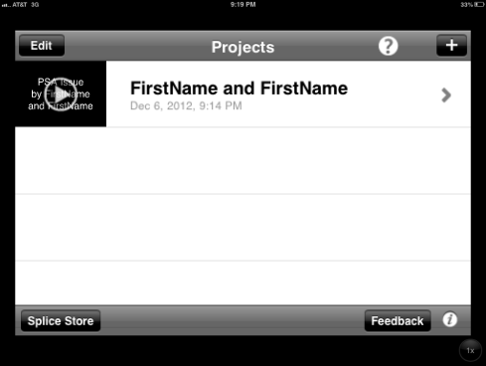

7. Edit OR Duplicate OR Delete

1. Change speed
2. Tap to Edit

3. Pick settings

**FirstName and FirstName**

1. Name project
2. Start project
3. Add Transition or Video/Photo

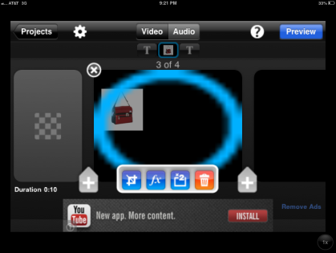

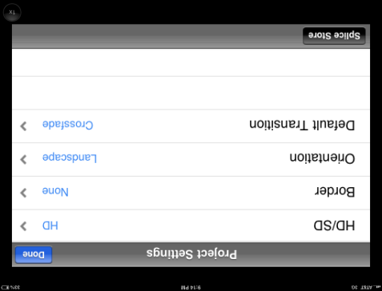

1. PHOTOS—Crop/Change Speed OR Filter OR Copy OR Trash

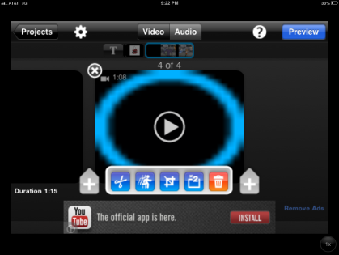

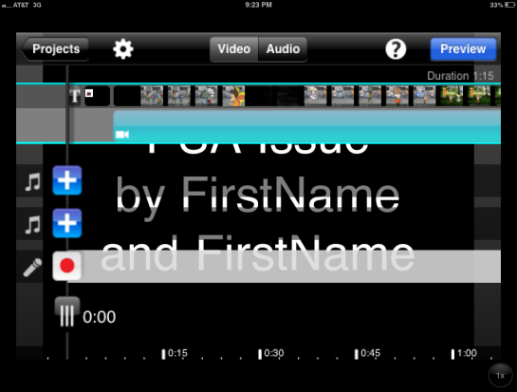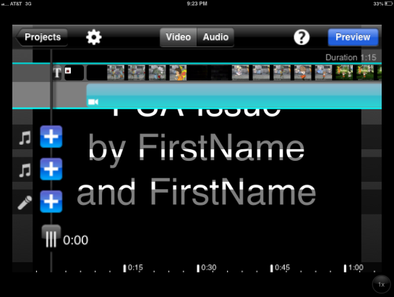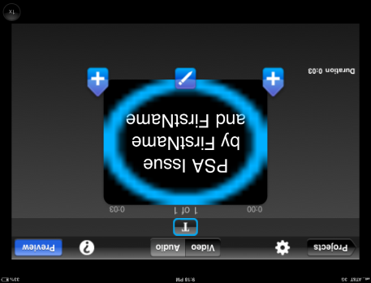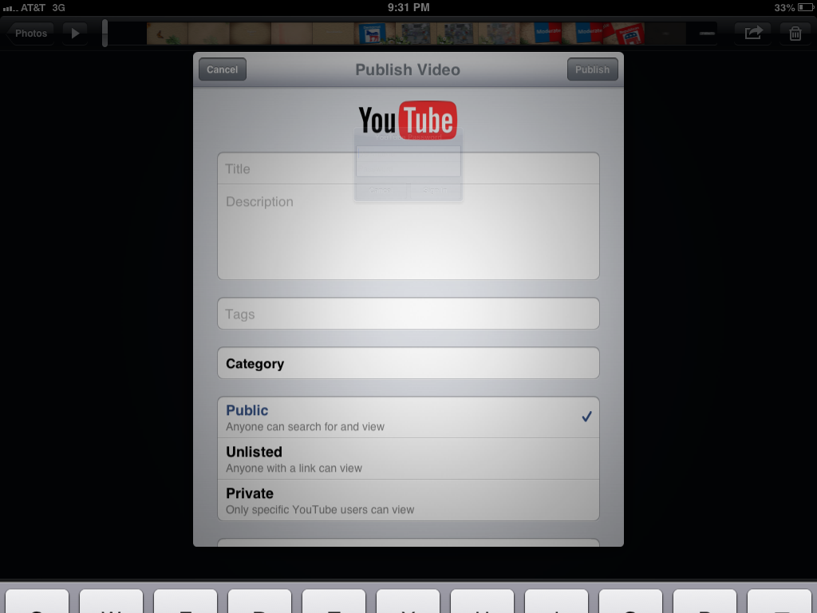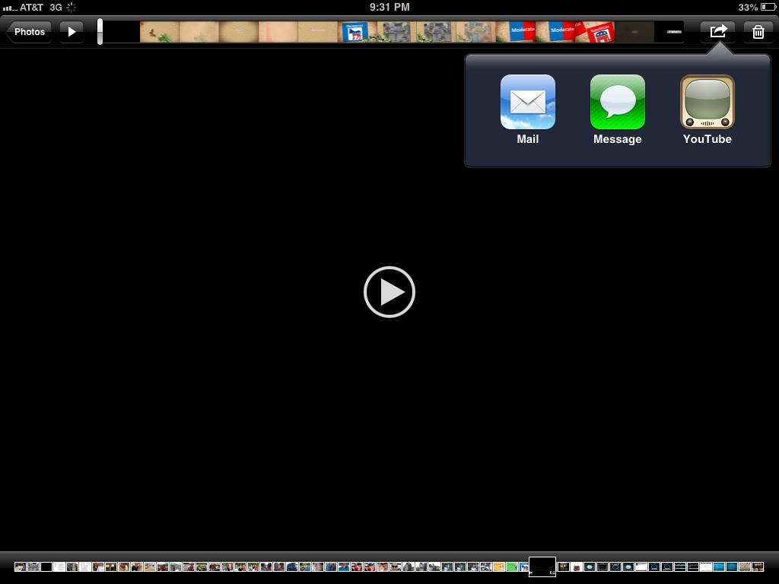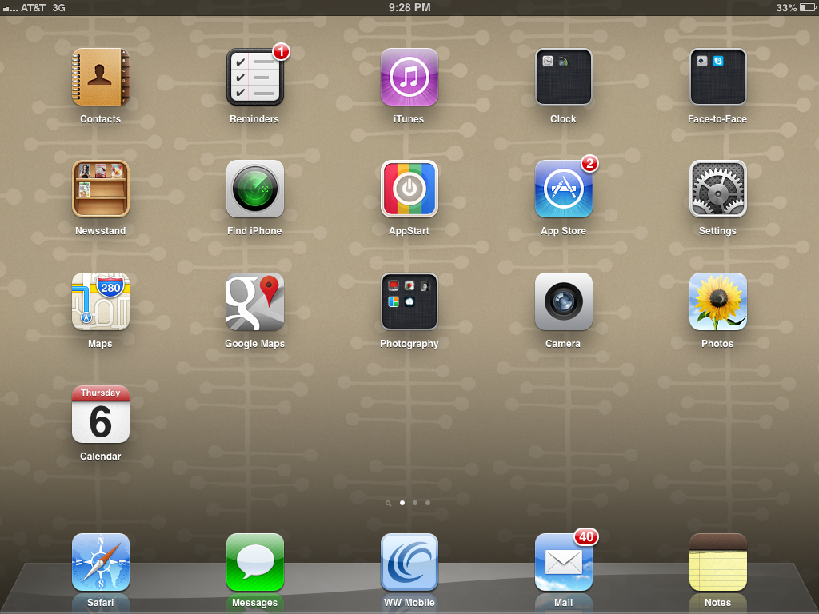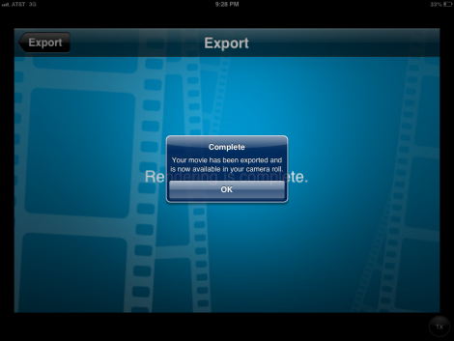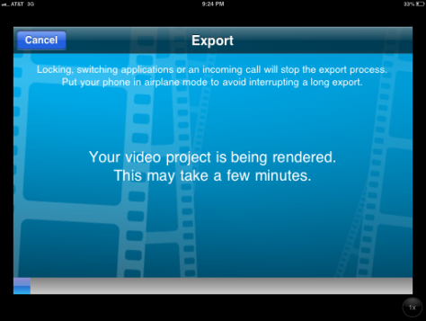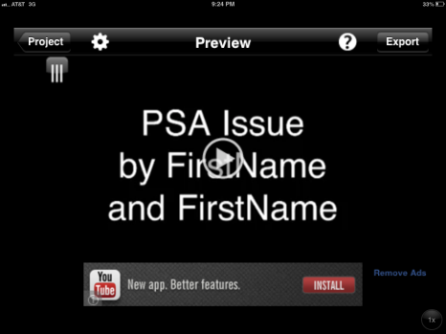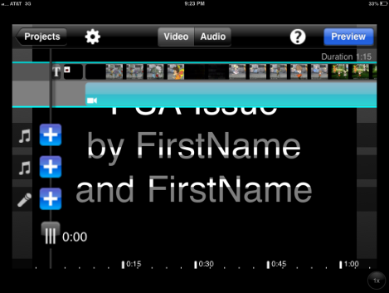

**ADD AUDIO ONLY WHEN ALL PICTURES/ VIDEOS/ TRANSITIONS ARE DONE!!!**

1. Tap to red dot to begin recording
2. Tap Audio To Narrate
3. Use Slide to determine recording location
4. Pick Next Element

**__Topic__ by FirstName and FirstName**

1. Add Title Slide
2. VIDEOS—Cut OR Change Speed OR Crop OR Copy OR Trash

ONLY FirstName and FirstName

English 9 PSA - __TOPIC__

Education

**GET HELP FROM YOUR TEACHER TO POST TO YOUTUBE!!!**

1. Post to YouTube
2. Tap Share
3. Find completed video
4. Check Camera Roll for video
5. WAIT! Wait for export
6. Satisfied? Export
7. Preview Video