STOP 6
Work individually for Part One.
** Non-profit organizations are important for solving world problems. You can get good information about important global issues from their websites.**
Part One Study the screen capture laminated handout. Complete all the steps on the handout. When you are finished – STOP – and get your work checked.
Work as a group for Part Two.
Part Two Work together with your group. When all people are finished with part one, get an envelope from the assistant working at this station. Work together to put together the citation puzzle in the envelope. When you are finished, you should have a correct citation for the website used in Part One. Each of you then should complete the Tour Guide Handout section for this station.

When you are done at this station ERASE what you wrote with dry-erase markers!

WEBSITE CITATIONS!
You must give credit to websites when you use information from them in a project or essay. Giving credit to the author or creator of the website is done through creating a CITATION.
A website citation includes:
Author(s). "Title of Article/Page." Name of Web Site. Site Publisher/Sponsor, Date of E-Publication. Web. Date of Access. <URL>.

You should try to find ALL information needed in the citation. If you cannot, you can leave parts out but you must be a DETAILED investigator and try to find all parts!
Here is a screen capture from the top of a website I want to use in my PSA project:
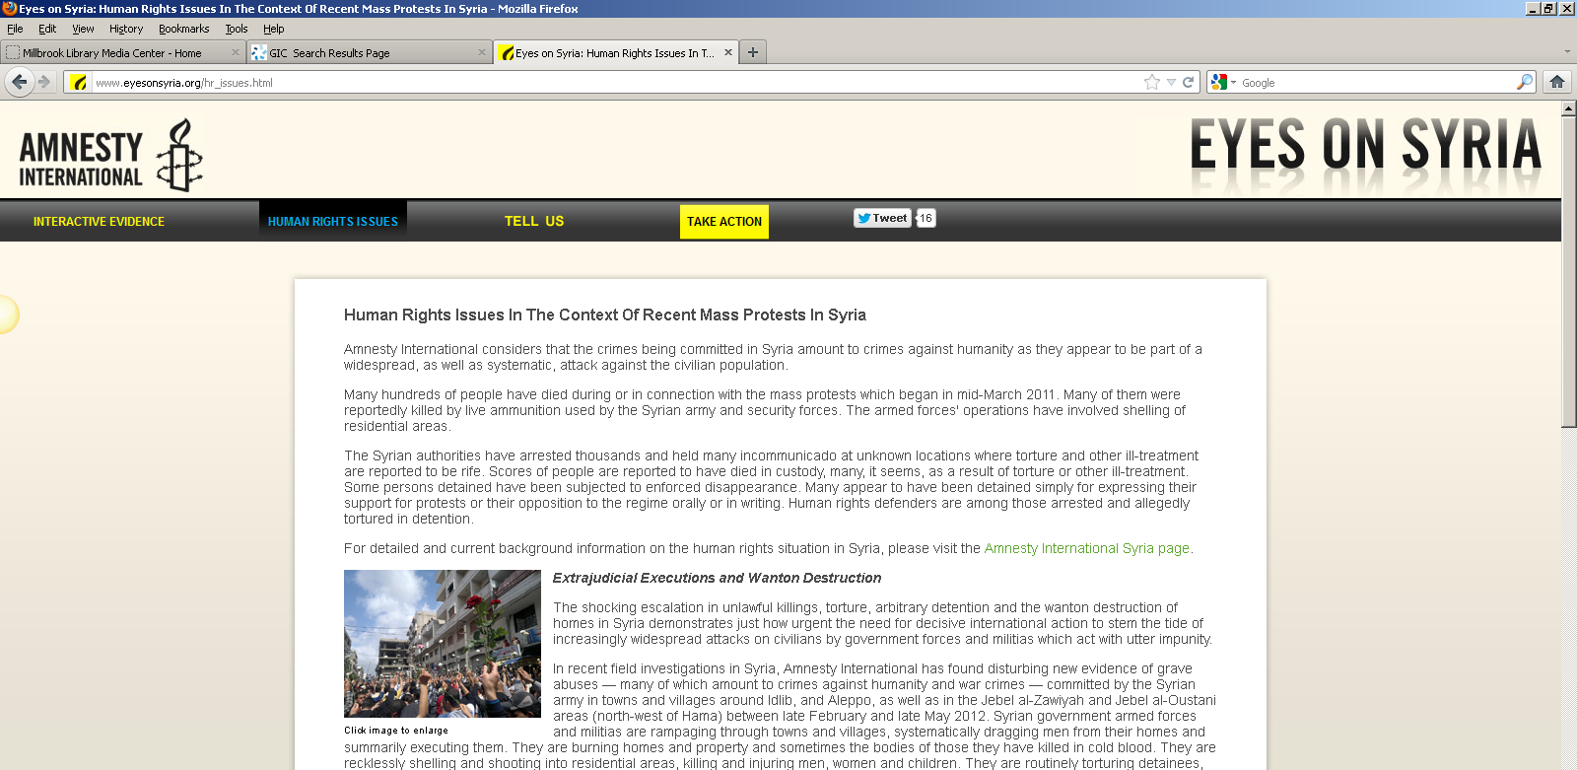
- On the screen shot above, use the dry erase markers and CIRCLE the name of the website and draw a SQUARE around the title of the article/page.
There is no author listed at the top of the page and there’s no date of publication for the website but we need to keep looking! Below is a screen shot of the bottom of the webpage:
- Draw a TRIANGLE around the date of e-publication for this website (the date on this site is just a year – there is no month or day listed).
We need to keep looking for an author! In this case I checked the Home Page and the “About” link for the website but I couldn’t find any authors. Here is a screen shot of the bottom of the Home Page for this website:
- There is no author but there is a publisher of the site. CIRCLE the publisher of this site.

"Human Rights in the Context of Recent Mass Protests in Syria."
Eyes on Syria.
Amnesty International USA,
2011.
Web.
16 Nov. 2012.
<http://www.eyesonsyria.org/hr_issues.html>.

